HARRISONS SABAH SDN BHD


D365FO DOT User Guide

DOT User Menu
To open the DOT Invoice Tracking form, navigate to:
HAR – Warehouse Operations > Operations > HAR – Warehouse DOT – Invoice Tracking.
Master Tables for DOT. Only Transporter Master maintain by Branches PIC
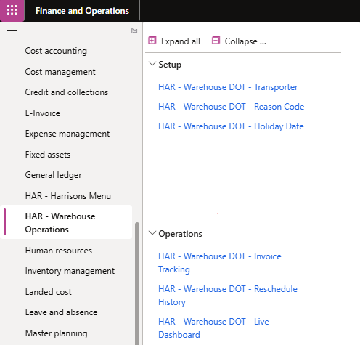
2. DOT Invoice Tracking form and Dashboard
1. Har - Warehouse Operations

DOT Transporter Master
To open the DOT Transporter Master form, navigate to:
HAR – Warehouse Operations > Setup > HAR – Warehouse DOT – Transporter.
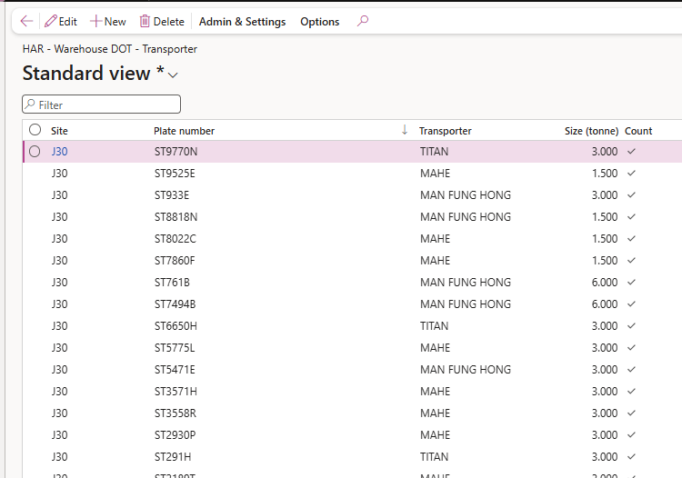
Tick means will be included in DOT report.
Edit , New and Delete

DOT Invoice Tracking form
By default, the list displays all invoices with an "Order Received" status. Users can filter this list using the options below.
To complete a DOT entry, follow these steps:
- New Shipment: Initiate when Item picks and loading.
- Update Shipment (Optional): Amend the loading information. Only Supervisor can access this page.
- Reschedule Shipment (Optional): Adjust dates if delivery timelines change.
Order entry menu
- Complete Shipment: Finalize and close out the shipment entry.
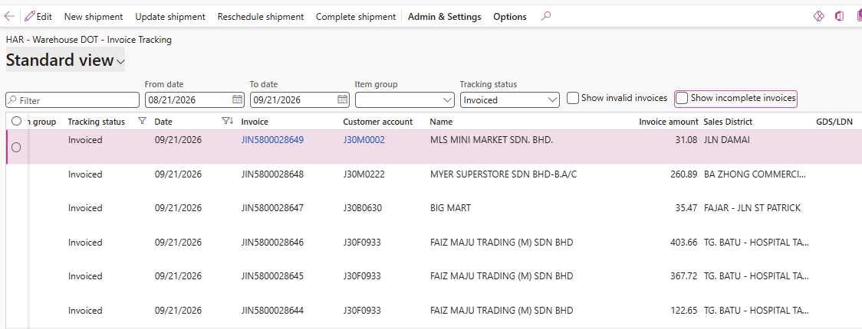
To show Failed Delivery with blank reason /Customer received Date
To Show tracking status “Loaded” and reason blank.
Filter options

- New Shipment
This process occurs when stocks are picked and loaded onto the lorry. To update multiple records at once, filter the invoices and use the bulk selection tool to group items with the same GDS, loading date, loading time, and transporter.
(Note: Saving these changes automatically updates the invoice tracking status to "Loaded".)
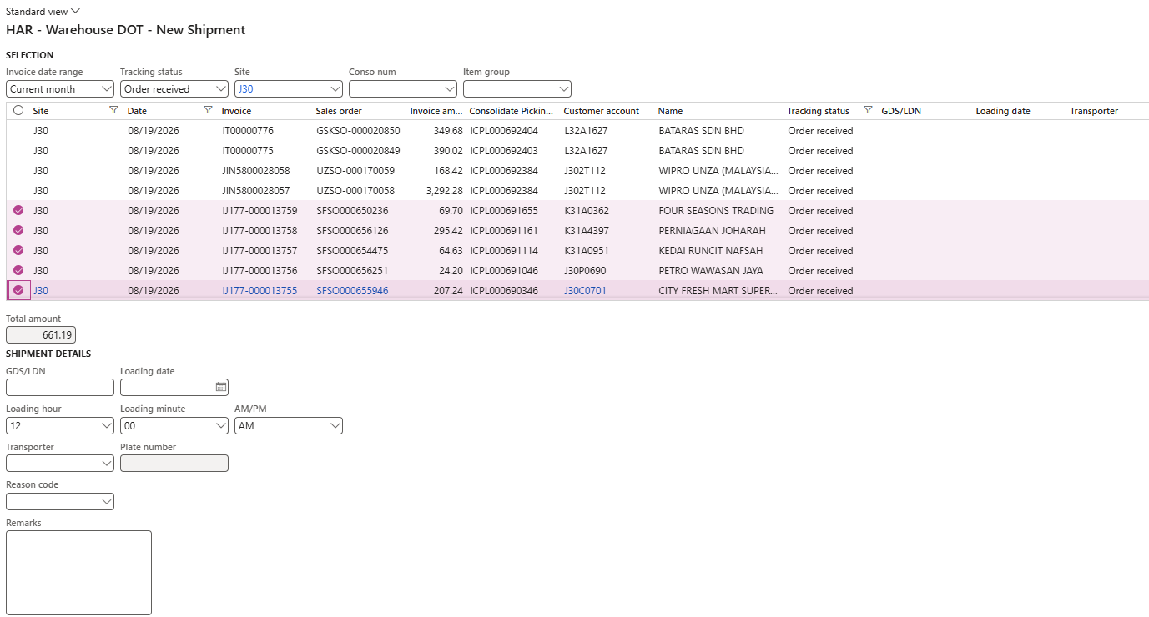
3. Update Details
4. Ok to save
2. Select the invoices
- Filter
- Update Shipment (Optional, only for PIC)
This option is only for certain PIC can access to make necessary changes if needed, it will load those transaction with status “Loaded” and “Cancelled”. (Note: Saving these changes automatically updates the invoice tracking status to "Delivered" if not cancelled.)

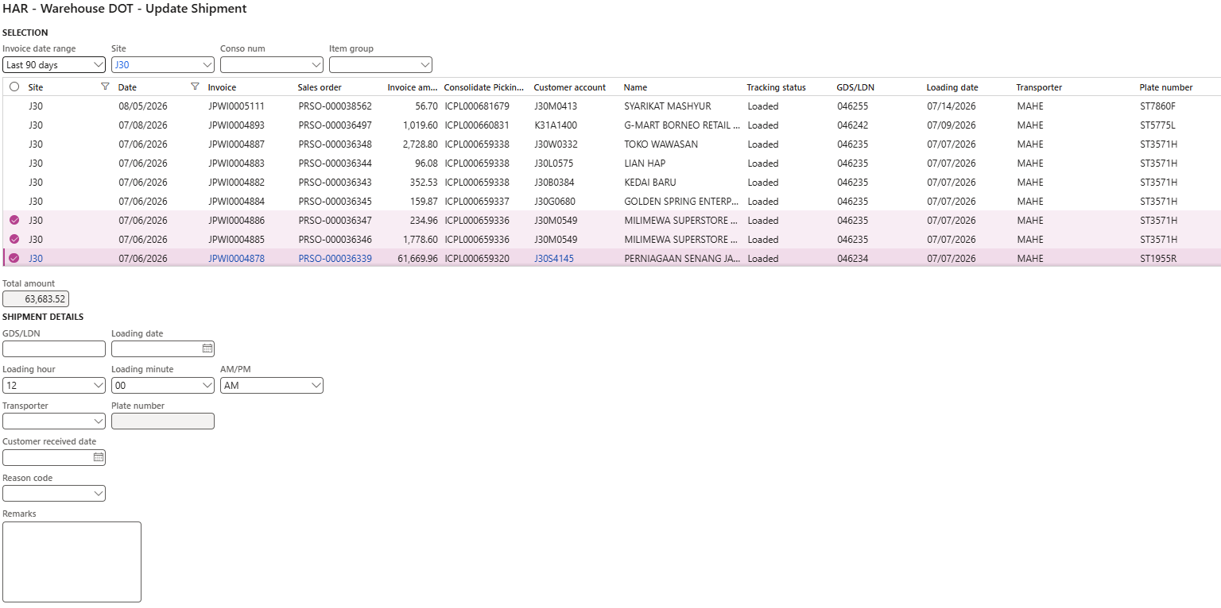
3. Update the customer received date only if all other details remain unchanged.
2. Select the invoices
- Filter
4. Ok to save

- Reschedule Shipment (Optional, only for PIC)
This is when the stock returned and reschedule for next delivery
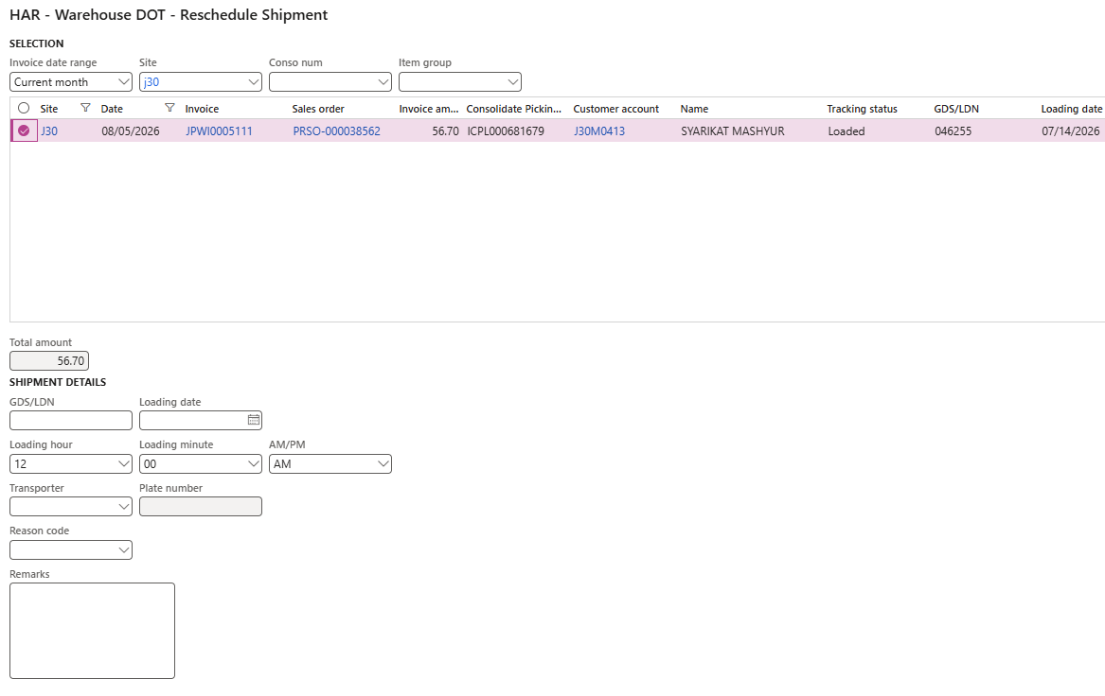
3. Update Details
4. Ok to save
2. Select the invoices
- Filter
- Complete Shipment Update Details
This process marks the final update once all deliveries are completed, it will load those transaction with status “Loaded” and “Delivered”.
(Note: Saving this step closes the shipment workflow.)

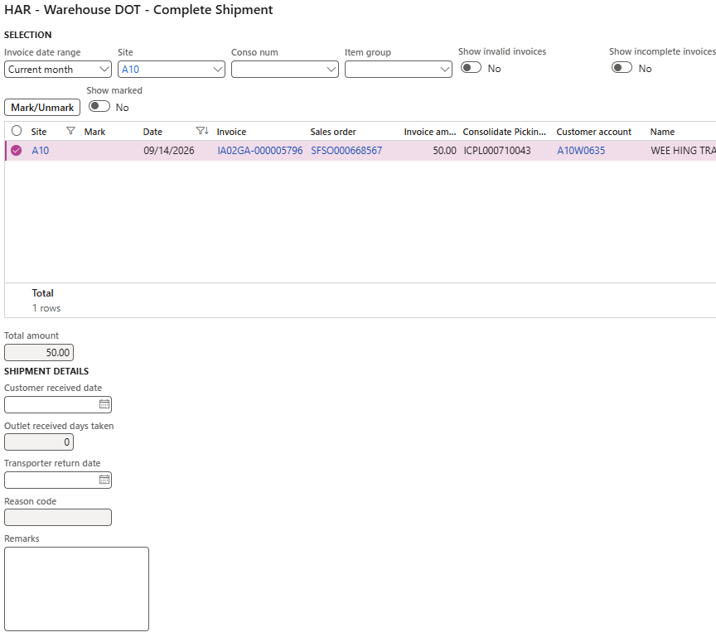
3. Update the Customer received date and Transporter return Date date.
4. Ok to save
- Filter
2. Select the invoices
Additional Note
*** Selecting a cancellation reason code will triggers a confirmation prompt. Once confirmed, the transaction is completed and no further information can be updated.

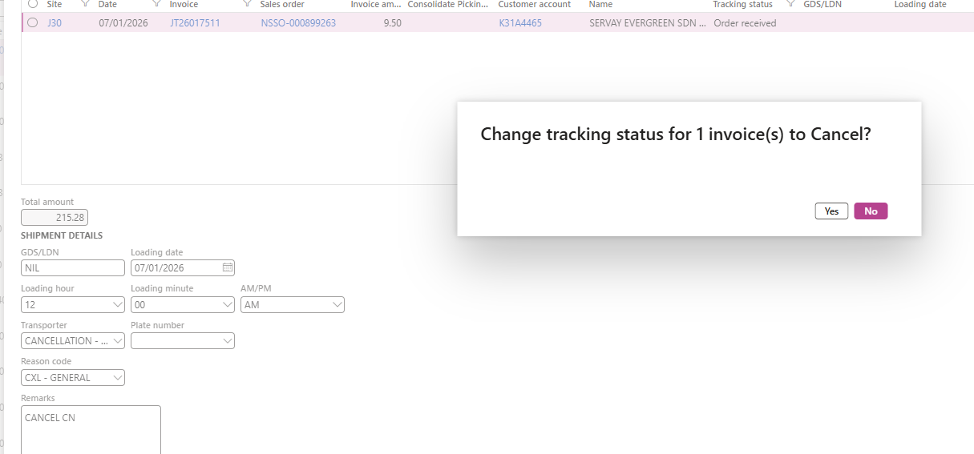
2. Yes to confirm
1. Reason code

